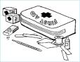
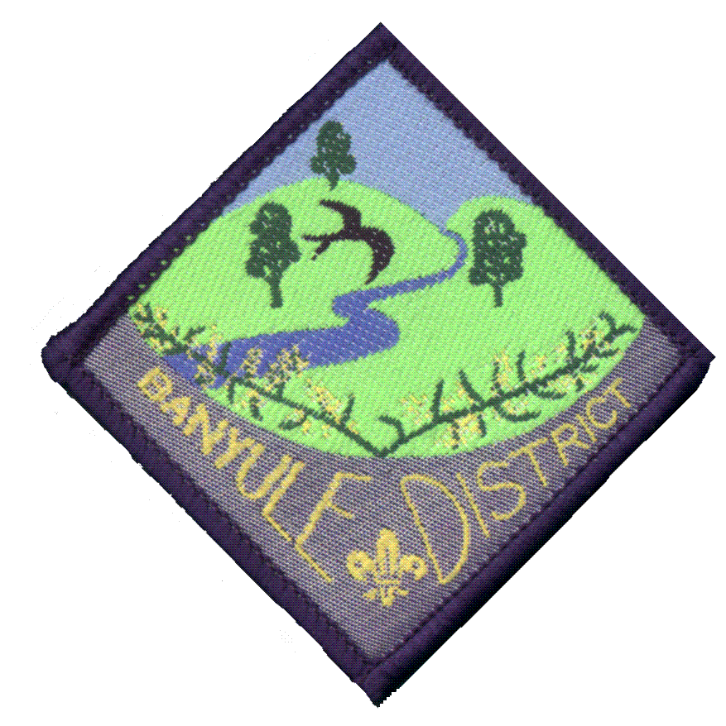
Banyule District Cub Scouts
First Aid Camp
5th - 6th June 2010

What is the First Aid camp?
The Camp is for the senior Cubs to gain further knowledge of first aid.
- Understand DRABC
Cost of $25.00 per Cub

- Put someone into the recovery position
- Treat a bleeding wound
The Camp starts Saturday 10am
Finishing around 2pm on Sunday

- Learn about snake bites
- Learn about spider/ insect bites
- Use of Phones in an emergency
All the information on the Level 2 First Aid Badge is available on Page 94 of your Yellow Book or at
www.rosannacubs.org/badge/badgeFirstAider.htm

Meet at 10th Ivanhoe Scout Hall, 52 Ford Street Ivanhoe (Melway 31 E6), in full uniform, for a 10 o’clock start.

You will need to bring
Sleeping Gear Sleeping bag and Pillow and Stretcher/mat/lilo
Clothes 2 changes, warm jumper, hat, waterproof coat
Sundries Toilet bag, Dilly Bag with plate, bowl and cup and cutlery, tea towel, torch, and Insect Repellent
Must bring a Personal First Aid Kit

Cut off bottom portion of permission slip and return to Akela by 1st June, plus -
NOTE: Places are limited, so if going, please first advise Akela ASAP on 9434 7594 or akela@rosannacubs.org

I give permission for my child:
of Rosanna Cubs
Name
Registration Number: ______________________ …to attend First Aid Camp on 5th to 6th June 2010

Special Instructions (food/allergies/medical):

Enclosed is $25.00. Method of payment: _______cash ________ cheque
Note: Please make cheques payable to the Banyule District Cub Scouts.

X
Parent or guardian signature Date

Banyule District Cub Scout Leaders Activity Team

